Hi, I am Dr Rajesh Walvekar, Cancer Surgeon.

This system is based purely on moving averages.

The Guppy MMA is the heart and sub window is the brain of the system.

**Indicators**: all indicators are colour coded to make chart reading easy

1. Trend envelops from 3 to 51. Special attention is to 3,9,21and 51.red blue lines with circle dot or star. (the values are seen in data window in the same order) 3 and 9 are to identify pullback continuation pattern. 21 is for stoploss 51 is for reversals.
2. APB candles: to reduce noise and keep trade running in existing trend as long as possible. Grey wicks mean consolidation. Lime candle with lime wicks and flat base indicate strong uptrend and vice versa. ABP candles also identify minor pullbacks.
3. RSIOMSA for over bought and oversold levels. Blue rsioma line on top of lime indicate strong upward momentum and vice versa
4. The Gann Hi-Low is to pinpoint exact entry candle. Change in trend indicated by vertical lines on chart.

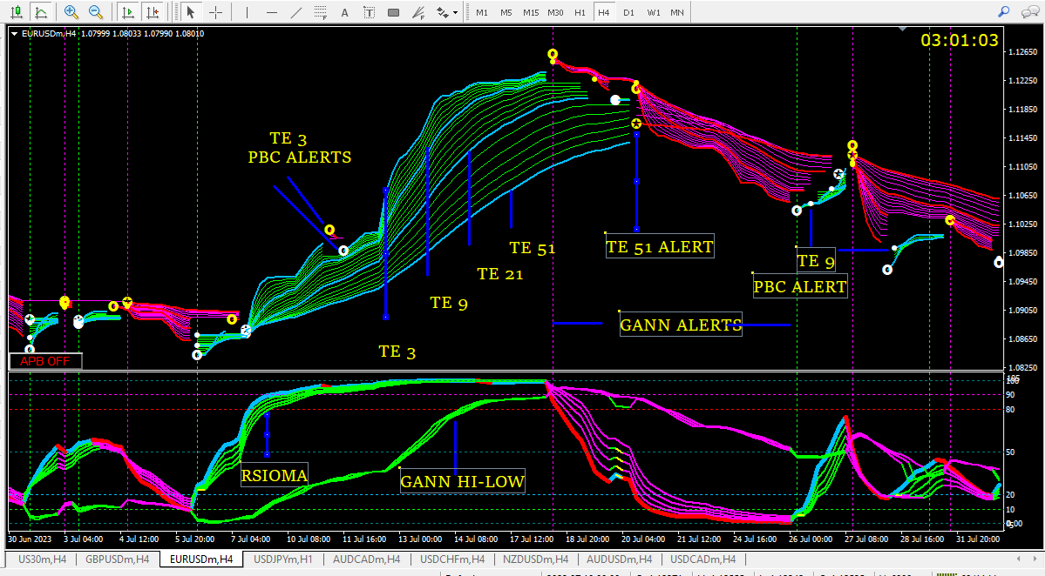

PLEASE NOTE:

I have modified the indicators to suit my chart and modified the alerts for easy understanding. I have also modified the names for my convenience. I mean no disrespect to the coders and apologise in advance.

I have spent hours and days in identifying these indicators and played with the settings to get best possible results. I request all not to add or remove any of these indicators. Use only my templet so all are on the same page.

Are so many indicators necessary?

Yes. they give visual understanding of the trend and make trading easy. A glance at the chart is sufficient and no extra analysis is required.

Do the indicators repaint?

No, they do not.

Why 3,9, 21 and 51?

Because 3 is my lucky number.

I do not trade in forex. I trade only in Indian equities and nifty index. So please don’t ask questions like currency pairs or sessions as I don’t understand them.

The trades I will be showing are in demo account. In real account trade at your own risk. Better to trade in demo account till you get used to the system.

Recommended time frame: M15 and above. I use M15 for intraday and H4 for swing trades.

AIM:

1. We have always heard the terms “buy on dip” and “sell on rally”. But it is very difficult to identify where the dip has ended, and the trend has resumed. We will pinpoint these candles to enter the trade. Identify high probability low risk trades.
2. To ride a good trend as long as possible.
3. Keep losses to a minimum.
4. Identify trend reversals at the earliest.
5. Remove fear once you are in the trade.

I will elaborate on all the above in due course.

ALERTS:

All alerts are at the close of the candle. It is recommended to wait for the candle close to make any trading decisions.

RTE 3 and 9: (white and yellow circle and dots, blue, red lines on chart and first and second values in data window) “PBC ALERT BUY” or “PBC ALERT SELL”. When alerted you should look at the chart to see if it is a pullback or continuation. If it is a pullback, wait for the opposite alert to trade.

RTE 21 has no alerts. 3rd value in data window. I use it to trail my stoploss if I am not monitoring the trade. Always trade with stoploss. I place stoploss immediately after entering any trade.

RTE 51: (white and yellow star in circle, blue, red line on chart and 4th value in the data window)

and

Gann Hi-Low Activator: vertical lines on chart

Alerts generated by both are “TREND REVERSAL BUY” or “TREND REVERSAL SELL” alert. When alerted look at the chart. if all indicators on the alert candle are of same colour take a trade. Red/Magenta sell, blue/Lime buy.

COMMON RULE FOR ALL ENTRIES: All indicators should be Line/Blue for buy and Red Magenta for sell. If not wait for next candle to close and see the colour. Preferred buy entry when RSIOMA is below 50 and vice versa.

PULLBACK CONTINUATION TRADE ENTRY: “buy on dip” and “sell on rally”.

RTE 3 and 9: (white and yellow circle and dots on chart and first and second values in data window) “PBC ALERT BUY” or “PBC ALERT SELL”. When alerted you should look at the chart to see if it is a pullback or continuation. If it is a pullback, wait for the opposite alert to trade.

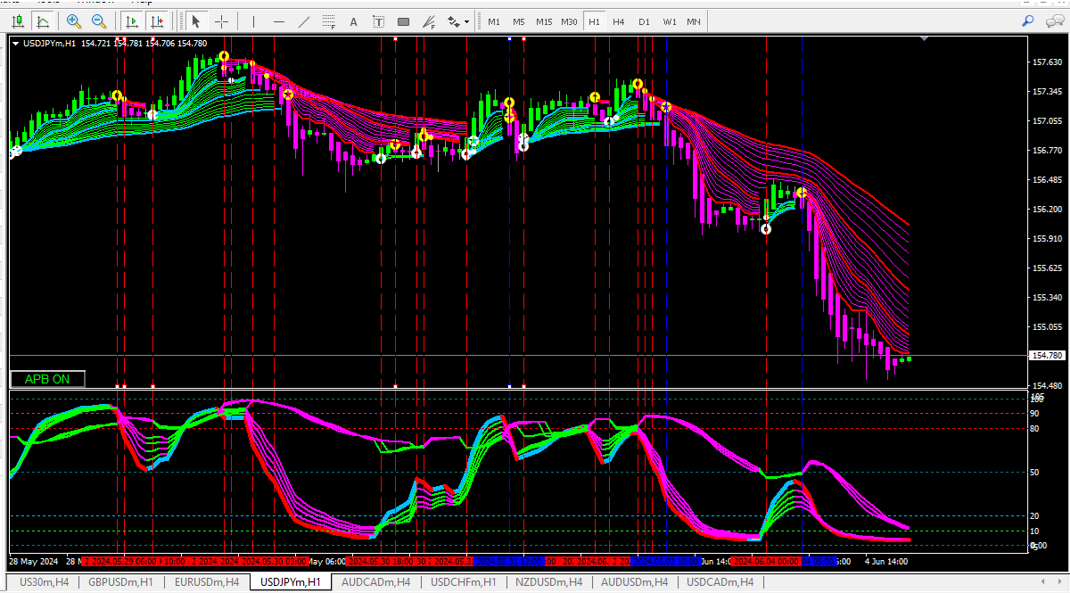

Only blue lines are tradable alerts. Red lines are not because all indicator colours do not match.

This is also how we filter trades to find high probability trades.

Another method of PULLBACK CONTINUATION TRADE ENTRY: “buy on dip” and “sell on rally”.

Especially when the candles are too large, wait for opposite colour APB candle to form. Then go to lower timeframe and wait for alert in original trend direction.

Picture shows downtrend with large candles on H4. When lime APB is formed (marked with red vertical line)

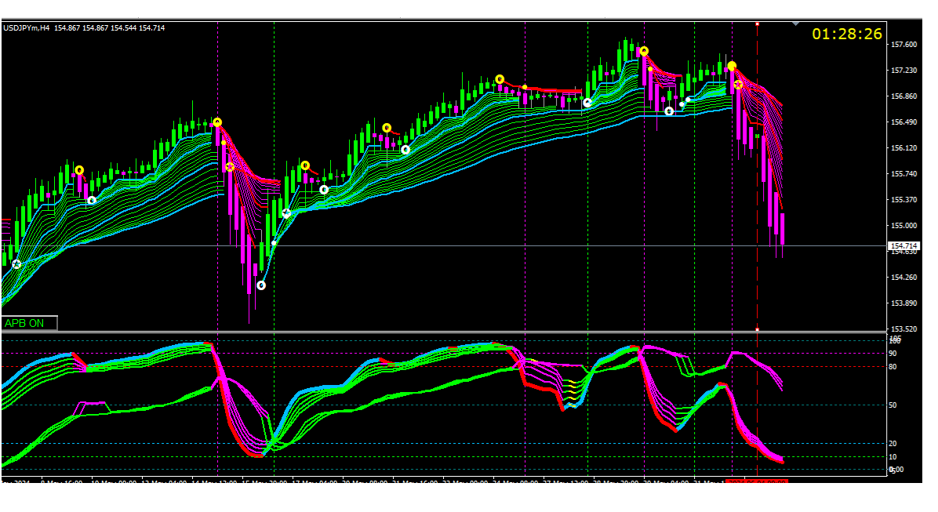

H1 chart shows exact entry after the red line: PBC Alert followed by Gann alert.

REMEMBER: before taking the trade, confirm that the trend in higher time frame is intact.

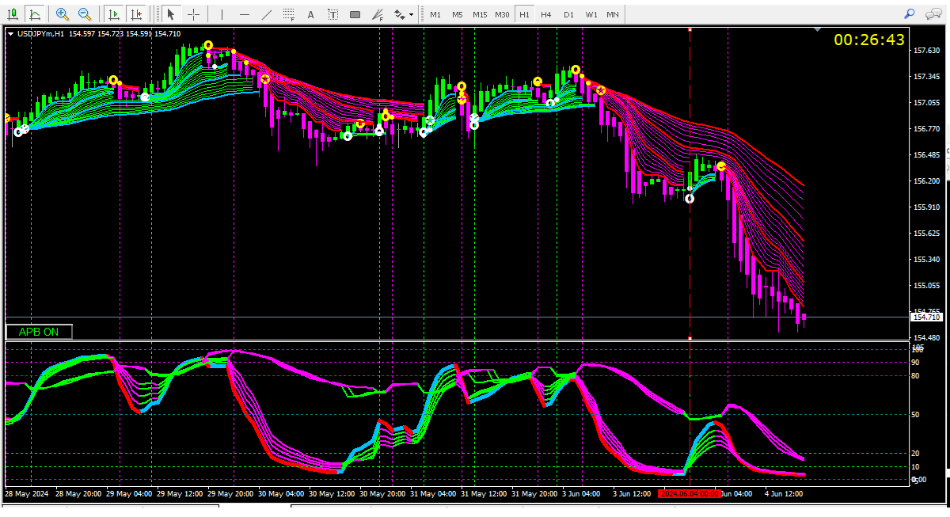

TRADING MINOR PULLBACKS: “buy on dip” and “sell on rally”.

REMEMBER: The guppy trend is intact in these pullbacks and no candle or wicks are beyond the RTE 51 line.

This is where BestTraderEv’s EA is going to help us especially if you are away from the screen.

In a trend, look for these small flags created by trend envelops. They will be followed by RTE 3 PBC ALERT. Enter at the close of the candle.

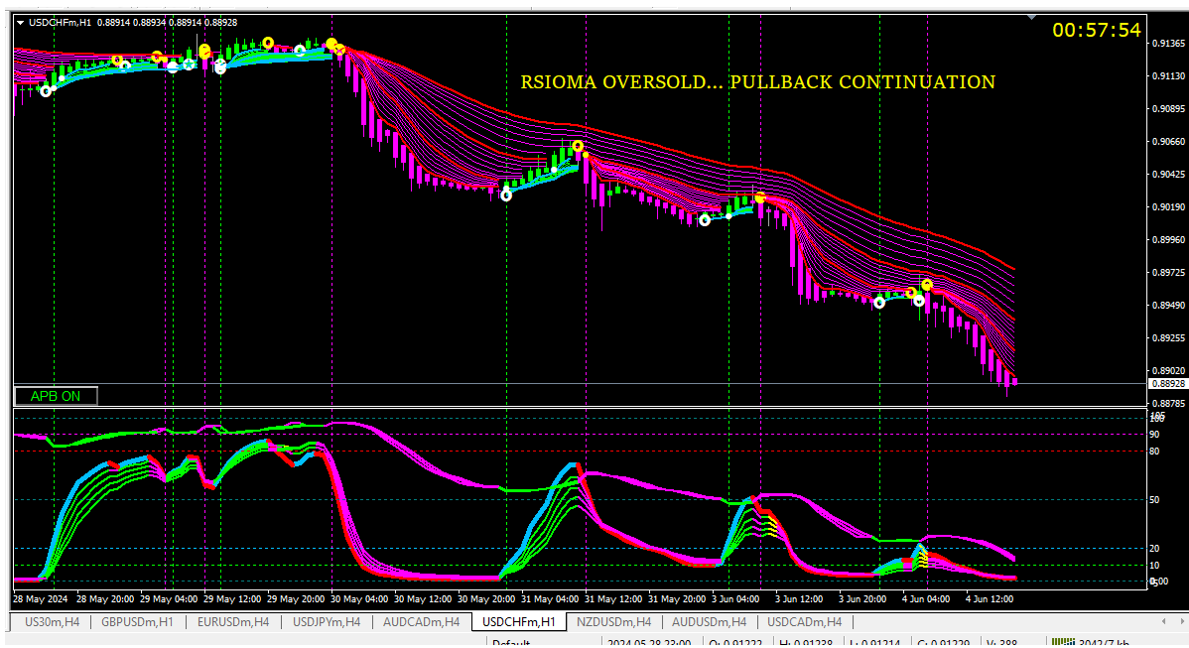

1. TREND REVERSAL ENTRY: “Identify trend reversals at the earliest.”

Specific criteria and rules for this. All criteria need to be fulfilled to enter the trade.

These are risky trades and should be traded with strict stoploss.

1. RSIOMA AND GANN BOTH must be in overbought zone (above 80) to go short and oversold zone (below 20) to go long.
2. GANN trend reversal alert with vertical line on chart.
3. On the alert candle the RSIOMAS should cross the 80/20 line.
4. Red RSIOMA should be below Magenta for sell and blue above lime for buy trade.
5. The RSIOMA and GANN lines should form a picture like open scissors on the entry candle.

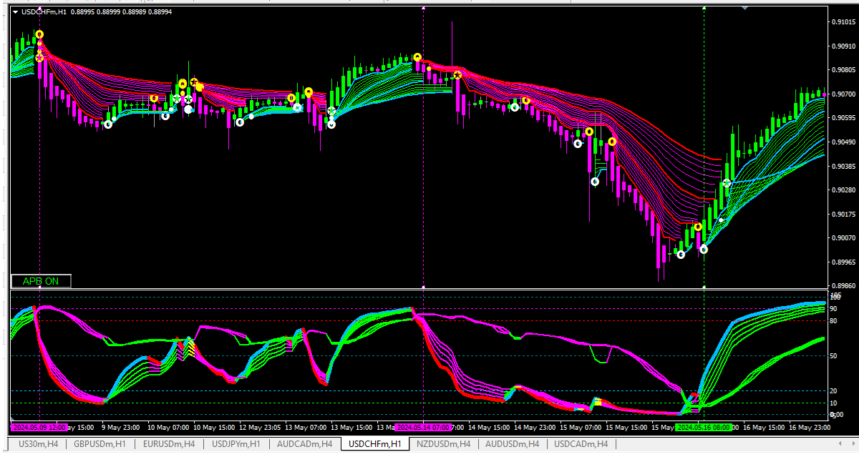

If you scroll the chart, you will find that the Gann lines change their position in sub window. don’t worry. During live trading, this open scissor formation should be in over bought or oversold area to trade.

Reversal trades taken on trend envelop 51 alert (star inside circle ) are safer with less risk.

“To ride a good trend as long as possible.

“Keep losses to a minimum.”

“Remove fear once you are in the trade.”

Let us read this trend between the 2 yellow arrows:

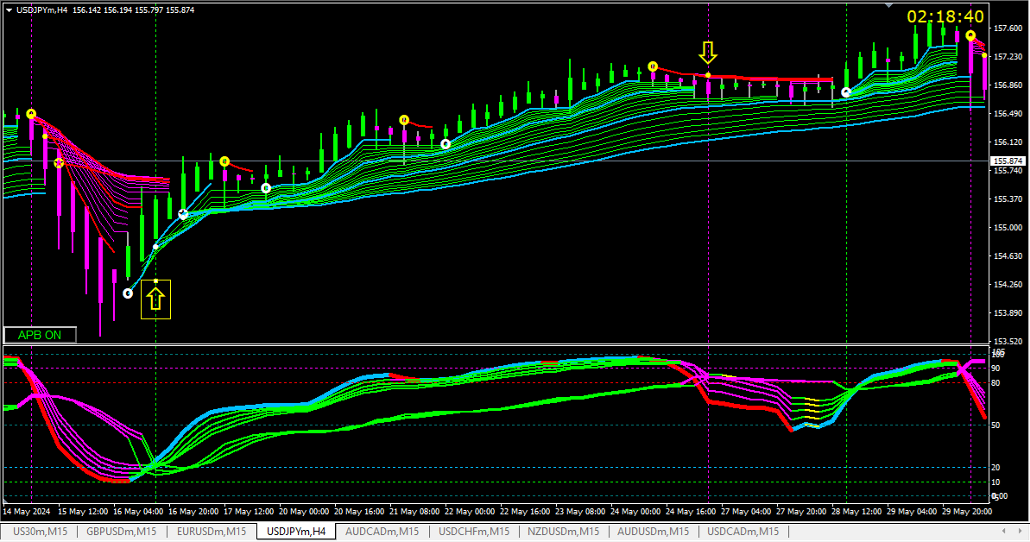

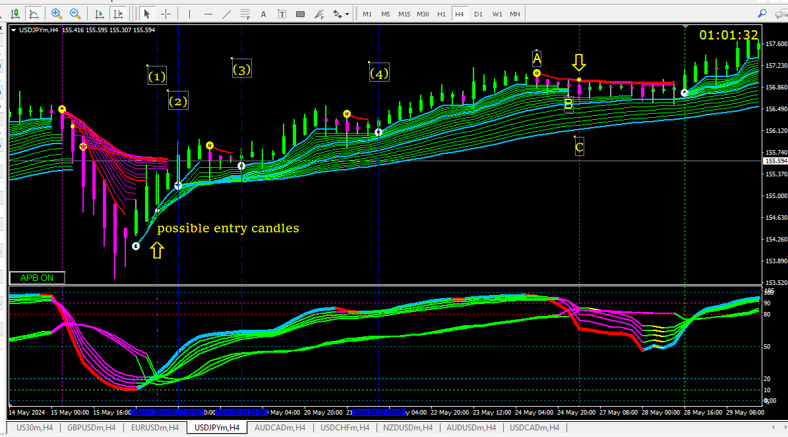

Possible entry candles are marked by blue lines.

1. Gann trend reversal alert. Scissors like formation in sub window.
2. Trend envelope “trend reversed buy” alert.
3. and (4) trend envelope “PBC buy” alert.

If you have entered the trade in at any one of these candles.

The APB candles are bullish or sideways.

The Guppy and Gann have remained bullish.

The Rsioma is blue over lime.

At the end of the trend

The APB candle has become bearish.

The sub window indicators have turned bearish.

So, the trade should be squared off at

1. trend envelope “PBC SELL” alert
2. trail SL at trend envelope 21. (third value in data window)
3. APB bearish candle/Gann “trend reversed sell” alert.

My method of trading: I enter with 2 lots. My initial stoploss is previous swing high/low. As the trade progresses, I shift SL to trend envelope 21 (third value in data window). I square off one lot with R:R 1:1 . second lot I carry till I get a opposite signal.

I square off irrespective of profit/loss if

1. Opposite colour bullish or bearish APB candle.
2. All rsioma change to opposite colour.

Wish you all happy trading.

Dr Rajesh Walvekar

Cancer Surgeon

Nashik, India.